https://www.epoka.edu.al/images/logo.png

Clinic Management System

Requirements Specification

Version 2.0

Faculty of Economics and Administrative Sciences

Business Informatics

June 5, 2019

Clinic Management System

Submitted by:

Besa Gashi

Anilda Disha

Gerjan Kallcishta

Ina Dezhgiu

Sindi Begteshi

Xhejdi Coku

Received by: Igli HakramaTable of Contents

1. Executive Summary 3

1.1 Project Overview 3

1.2 Purpose and Scope of this Specification 3

2. Product/Service Description 3

2.1 Product Context 3

2.2 User Characteristics 3

2.3 Assumptions 3

2.4 Constraints 3

2.5 Dependencies 4

3. Requirements 4

3.1 Functional Requirements 5

3.2 Non-Functional Requirements 5

3.2.1 User Interface Requirements 5

3.2.2 Usability 5

3.2.3 Performance 6

3.2.4 Manageability/Maintainability 6

3.2.5 System Interface/Integration 7

3.2.6 Security 8

3.2.7 Data Management 8

3.2.8 Standards Compliance 8

3.2.9 Portability 8

3.2.10 Other Non-Functional Requirements 9

3.3 Domain Requirements 9

4. User Scenarios/Use Cases 9

APPENDIX 10

Appendix A. Definitions, Acronyms, and Abbreviations 10

Appendix B. References 10

Appendix C. Requirements Traceability Matrix 10

Appendix D. Organizing the Requirements 12

# Executive Summary

## Project Overview

Nowadays the importance of technology is getting bigger with every minute passing by. Also with the population rate increasing in a high pace, it is being harder to keep track of all the information inside a business. When it comes to a medical clinic, a patient’s information should be kept in maximum security and there’s when technology makes this task very easy. To make an administrator and staff’s work easier, we thought of creating a software, which will be used by them.

This software intends to make keeping track of patients, supplies, workers, and financial activities easier than before.

## Purpose and Scope of this Specification

The purpose of this specification is providing a detailed and précised information. Regarding the target audience, this software will be used by the administrator and the rest of the staff, so they can have better and faster communication, thus making their daily tasks easier.

Furthermore this system aims to:

1. Make medical analyses in a faster and efficient way.
2. Give results in a shorter time than usual.
3. Keep records of patients and protect their privacy.
4. Improve decision making across finance, medical staff etc.
5. Manager has access non-stop to see how the staff is working, thus making it easier to make decisions

# Product/Service Description

## Product Context

Clinic Management System will be created in such way to give a helping hand to the persons who will use it. It aims to better keep track of suppliers, staff employees, salaries and patients.

## User Characteristics

Users that are going to have access on the software include :

1. **Administrator:**
   1. Can add new users.
   2. Can manage the users login credentials.
   3. Will give access to the users .
   4. Will have access to the whole system.
2. **Financier**

1. Will deal with salaries.

2. Will record invoices.

1. **Medical Staff**

1. Can view their patients.

2. Can update their information.

1. **Receptionist**

1.Set appointments for new patients.

2.Generate receipts.

## Assumptions

# It is assumed that this system will be accessed from the web browser over the computers as long as they have connection to the internet.

# It is assumed that the administrator will be the first user that can have access in the system , so that he/she can add the other users.

# It is assumed that only the doctor will have access over patient’s information and this information is fully confidential.

## Constraints

* Every user should have their own computer so that it is easier for them to use the system.
* Since it will be a web application it will require a good and established connection to the internet for full time usage.
* Users should keep communication during all working hours for them to have a more efficient work and take better decisions.

## Dependencies

Since the administrator has the main access to the whole system, there are some dependencies which need to be taken into consideration:

* If the administrator is not registered to the system, other users can not be registered.
* If the financier does not make reports, admin will not be able to see them and make decisions.
* If receipt is not generated, the revenue will not be included in the balance sheet.

# Requirements

## Functional Requirements

Priority Definitions

* Priority 1 – The requirement is a “must have” as outlined by policy/law
* Priority 2 – The requirement is needed for improved processing, and the fulfillment of the requirement will create immediate benefits
* Priority 3 – The requirement is a “nice to have” which may include new functionality

The requirement numbering has a scheme - BR_0## (BR for Business Requirement).

|  |  |  |  |  |  |
| --- | --- | --- | --- | --- | --- |
| Req# | Requirement | Comments | Priority | Date Reviewed | Approved |
| BR_01 | The system should have a Software  which will be used by 4 different users. | They will be the Admin,Finance department, Medical staff, Receptionist | 1 | 2/03/19 | Besa Gashi,  Anilda Disha |
| BR_02 | The manager(admin) will give access to other users | He/She will provide them with login information. | 1 | 2/03/19 | Besa Gashi,  Anilda Disha |
| BR_03 | The manager will update users. | In case if the employees will change there will be a need for some updates | 1 | 2/03/19 | Besa Gashi,  Anilda Disha |
| BR_04 | Manager will generate reports. | He will generate reports to see how is going the overall situation in company. | 1 | 2/03/19 | Besa Gashi,  Anilda Disha |
| BR_05 | Manager will generate graphs. | They will help him of the company to take best decision. | 1 | 2/03/19 | Besa Gashi,  Anilda Disha |
| BR_06 | The receptionist will take the record of the patients. | These records will be registered on the system. | 1 | 2/03/19 | Besa Gashi,  Anilda Disha |
| BR_07 | The medical staff will view all the patients and their records, also their tests. | They will update the results online on the system, and also give a short description of the test results. | 1 | 2/03/19 | Besa Gashi,  Anilda Disha |
| BR_08 | Admin will register and manage all the employees. | All the employees’ information should be in the system. | 1 | 2/03/19 | Besa Gashi,  Anilda Disha |
| BR_09 | Admin will delete and update the employees and the information. | They should always be ready for future changes on the staff or their informations. | 1 | 2/03/19 | Besa Gashi,  Anilda Disha |
| BR_10 | The finance department will keep the inventory records. | All inventory records should be in the system, in order to make the better use of the materials needed for the tests, The materials used are very expensive so this process will define the amortization time and help the manager to make better decisions. | 2 | 2/03/19 | Besa Gashi,  Anilda Disha |
| BR_11 | The finance department will make the balance sheets and other financial statements needed for the operations. | This will help the manager to evaluate also the performance of the business, even though this is a medical service, in the end it is still a business. | 2 | 2/03/19 | Besa Gashi,  Anilda Disha |
| BR_12 | The finance department will also calculate the salaries. | Finance will calculate the salaries and then pass it to admin. | 1 | 2/03/19 | Besa Gashi,  Anilda Disha |
| BR_13 | The manager (admin) will have access in every part of the system. | In order to make better decisions and also make evaluations. | 1 | 2/03/19 | Besa Gashi,  Anilda Disha |

## Non-Functional Requirements

### User Interface Requirements

Our application will be a software; that will be placed on the computer of the clinic.

The first page is going to be a page with 2 big divisions, admin and users, the admin will be the manager, he will have access all over the system. And the second division (users) will be for the staff, medical staff, receptionist and finance department. Then the second page will be the log in with an email and password for each user that will be provided form the manager.

Our system will consist of several modules, providing that it will manage the whole business. These modules are the employee module, medical tests module, the patients’ module, the finance module and the report module.

The manager is responsible for adding new users, such as medical staff, receptionist and financiers, to the system, managing the existing ones and viewing their details. After registering a new user, he/she will provide them with their login information so that they can access the system.

On the other hand, the receptionist will keep the record of the patients and register these informations on the system. The medical staff will make the tests, will see all of the patients’ records and update the test results on the system. The finance will manage the financial part of the system, prepare the financial statements, keep and manage the inventory, also calculate employees’ salaries.

The admin will add new employees, manage existing ones and also manage departments.

### Usability

* The system is easy to use.
* It will be built in such a way that every operation will be context sensitive and obvious to how it works, in order that all users to understand and do their jobs in a more efficient way.

### Performance

* Users will have a high performance in completing a specific task of the management system.
* Most of them will be able to use the system very well, without the need of help from the system builder.

**Productivity**

* The system will be productive meaning that all the tasks will be accomplished easily with the least amount of work and time.
* There will be few or no user errors.

**Accessibility**

* The system will be accessible at any time by every registered user on the clinic property.

**User friendliness**

* The system will be delightful to use.
* It shall not be intimidating, frustrating and look as though it demands a lot of time and effort to complete a simple task.

**Error tolerance**

* The system shall be created in such a way that it will leave no room for error.
* It will be difficult for a simple task to go wrong.

**Effectiveness**

* The software will aid that all the emplyees to accomplish their job in an effective way and in a shorter time by providing easy tools.

**Efficiency**

* The system shall provide to the users a fast and reliable way of completing their respective tasks promptly with no difficulties and errors.

### Performance

Based on the interviews we made with the manager, we planned software most critical scenarios:

* Registration of the client.
* Generate the price client has to pay depending on the laboratory test they want.
* Management of sales from finance department, and other finance activity including balances and inventories.
* Information update of test results

#### **Capacity**

While analyzing the current and forecasting the future demand, we came up with this capacity planning:

Total number of users: 30

Number of current users: 20

80% - 90% of the transactions are accepted to complete within 2 seconds.

If in the future we lack of capacity, we will consider to add additional applications and database servers.

#### **Availability**

The software with be geographically restricted in Albania territory.

It will be functioning 16h a day, since the information is accepted to be received daily.

The system needs a high availability and the impact of a downtime on users would be serious. The period of time when the system may be offline to be improved may be some few hours in Sunday. That will give an impact on users in the financial and medical staff department, but at least will not affect the department that deals with clients, because the clinic does not operate on Sunday.

#### **Latency**

Speed of the transactions will be faster than 50ms.

### Manageability/Maintainability

#### **Monitoring**

We will ask reports from managers and staff that use the software for the problems they have faced, while proving the software, in order to fix them. We will check beforehand response time, transactions per seconds, user logged in, database response query, networking monitoring etc.

#### **Maintenance**

The system will be very simple to use and the models are separated from each other with means that the transaction will occur separately, databases will loaded and the activities easy to process. But except of this, we will still make our test in order to define problems before occurring or fix the existing ones. For this will help preventive and corrective maintenance.

#### **Operations**

* Add new user, medical staff, financier, receptionist.
* Log in to access the system.
* Keep record of patients.
* Register information in the system.
* Update test results to the system.
* Prepare the financial statements.
* Calculate employers salary.

### System Interface/Integration

#### **Systems Interfaces**

The system will use protocols of HTTP and HTTPS and also SQL technologies since we will use databases for the clients and staff.

The system will use internet connection as the networking interface.

Based on their position inside the business, different users will have different functionalities.

Since we are restricted in Albania territory, there will be no changes in the time zones.

### Security

Protection

* Cloud Firestore Security Rules allows us to control the access of the documents and collections in our database.
* The flexible rules syntax allows us to create different rules that match everything, from all writes to the entire database to operations on a specific document.
* Every request to write or to read something will be completed if only our rules allow it
* Our rules do not allow anyone to access our database.
* Using security rules allows us to write conditions that can check user authentication, validate incoming data, or even access other parts of our database.
* This is to protect our database from any abuse until we have time to customize our rules or set up authentication.

### Data Management

* Cloud Firestore is a NoSQL, document-oriented database
* Unlike a SQL database, there are no tables or rows
* Instead, we store data in documents, which are organized into collections
* Each document contains a set of key-value pairs
* All our documents will be stored in collections. Documents can contain sub-collections and nested objects, both of which can include primitive fields like strings or complex objects like lists.
* Collections and documents are created implicitly in Cloud Firestore. If document or collection does not exist, Cloud Firestore creates it.

### Standards Compliance

Our application “Clinic Management System” it’s going to respect and fulfill the rules and regulations determined by “LIGJI Nr.9887, datë 10.3.2008, PËR MBROJTJEN E TË DHËNAVE PERSONALE” to provide discretion to the patients.

Also, to “LIGJI Nr. 10 383, datë 24.2.2011 PËR SIGURIMIN E DETYRUESHËM TË KUJDESIT SHËNDETËSOR” for a good and efficient health care service for the patient. Finance department it’s going to take care of generating the bills and also the reports, according to “Drejtoria e Pergjithshme e Tatimeve”.

Our system it’s going to include all the fields and services of the clinic, in a more optimized way, providing the best service for our clients.

### Portability

Our system will be web-based, which can be accessed by any computer regardless the operating system. We are going to program our software by using PHP, HTML5, JavaScript and Bootstrap.

## Domain Requirements

Clinic Management System is aimed to keep track of patients, supplies, workers, and financial activities inside a clinic. This will help the business to be better organized and base their decisions in detailed reports and information.

Since when it comes to medical data the security and confidentiality are at a peak importance, the result of the lab tests of patients will be seen only by the doctors who performed them. The front desk or receptionists will have access to only the patients list making it able for them to add new patients at registration. The HR specialist will see the information about the employees. The financial specialist will have access to the financial records like receipts, suppliers etc.

The administrator of the clinic will be able to access information about all the departments , leaving out of course the confidential information about patients like their test results.

# User Scenarios/Use Cases

|  |  |  |
| --- | --- | --- |
| **Nr** | **Scenarios** | **Description** |
| **1** | Log in as Admin. | Logs in by using username and password. |
| **2** | Admin fails to log in. | Fails to log in because the username and/or password may be incorrect. Try again. |
| **3** | Admin opens patient’s database. | Can see patient’s list and make changes. |
| **4** | Admin opens employee database. | Admin has access in their database. |
| **5** | Admin updates employee database. | Admin can add or delete employees. |
| **6** | Log in as User. | Users include medical staff, receptionist, finance. |
| **7** | Log in as Medical Staff. | The doctor logs in successfully using username and password. |
| **8** | Medical Staff fails to log in. | Fails to log in because the username and/or password may be incorrect. Try again. |
| **9** | Medical Staff access patient’s database. | The doctor can see the patient’s list and add their test results. |
| **10** | Medical Staff updates patient’s database. | The doctor can add patient’s test results. |
| **11** | Log In as Receptionist | The receptionist logs in successfully using username and password. |
| **12** | Fail to log in as receptionist. | Fails to log in because the username and/or password may be incorrect. Try again. |
| **13** | Register new patients and select the required test and price. | Receptionist adds patients by name, surname, gender and email address. |
| **14** | Log in as finance. | The financier logs in successfully using username and password. |
| **15** | Fail to log in as finance. | Fails to log in because the username and/or password may be incorrect. Try again. |
| **16** | Finance opens the finance database. | Financier can see invoices from supplies, salaries of employees and receipts from tests. |
| **17** | Finance updates the database. | Financiers can edit the salaries of employees, correct any mistakes that could be made and submit all financial statements. |
| **18** | Admin can edit data of employees profile. | Admin can edit name, surname, username, password, employee bithdate, address, contact nr. |
| **19** | Medical Staff can only edit/change their own password. | Medical staff can’t edit or change other things in their profile except their password. |
| **20** | Receptionist can only edit/change their own password. | Receptionist can’t edit or change other things in their profile except their password. |
| **21** | Financier can only edit/change their own password. | Financier can’t edit or change other things in their profile except their password. |

**Scenarios Extended**

* 1. **User Scenario 1 - Admin logs in**

a. Admin enters username and password.  
b. Username and password are correct.  
c. Admin is successfully logged in the system.

* 1. **User Scenario 2 – Admin fails to log in**a. Admin enters username and password.  
     b. Username and/or password are incorrect.  
     c. Admin re-enters username and/or password.
  2. **User Scenario 3 – Admin opens patient’s database**  
     a. Admin logs in successfully.  
     b. Admin opens patient’s database.  
     c. Admin can see patient’s list and even make changes.  
     d. Admin logs out.
  3. **User Scenario 4 – Admin opens employee database**  
     a. Admin logs in successfully.  
     b. Admin goes to the employee database.  
     c. Admin can see employee list and information.  
     d. Admin logs out.
  4. **User Scenario 5 – Admin updates employee database.**  
     a. Admin logs in successfully.  
     b. Admin opens the employee database.  
     c. Admin can add an employee.  
     d. Admin can delete an employee.  
     e. Admin saves changes.  
     f. Admin logs out.
  5. **User Scenario 6 – Log in as User**  
     a. User referring to medical staff, receptionist, financier enters their credentials.  
     b. Username and password are correct.  
     c. User logged in successfully.
  6. **User Scenario 7 – Log in as medical staff**  
     a. Medical staff enters their username and password.  
     b. Username and password are correct.  
     c. Medical Staff are logged in the system.
  7. **User Scenario 8 – Medical Staff fails to log in.**  
     a. Medical staff enters their username and password.  
     b. Username and/or password are incorrect.  
     c. Medical staff re-enters username and/or password until they are successfully logged in.
  8. **User Scenario 9 – Medical staff access patient’s database**.  
     a. Medical staff logs in the system.  
     b. Medical staff opens patient’s database.  
     c. They can see their patient’s list.  
     d. Medical staff logs out.
  9. **User Scenario 10 – Medical Staff updates patients database.**  
     a. Medical Staff successfully logs in the system.  
     b. Medical staff opens patients database.  
     c. They add a test result.  
     d. Medical staff saves changes.  
     e. Medical staff logs out.
  10. **User Scenario 11 – Log in as receptionist.**a. Receptionist enters their username and password.  
      b. Username and password are correct.  
      c. Receptionist is logged in the system.
  11. **User Scenario 12 – Receptionist fails to log in.**a. Receptionist enters their username and password.  
      b. Username and/or password are incorrect.  
      c. Receptionist re-enters username and/or password until they are successfully logged in.
  12. **User Scenario 13 – Register new patients and select the required test & price.**  
      a. Receptionist successfully logs in the system.  
      b. He/She registers new patient.  
      c. He/She asks for patient’s name, surname, gender, and email address.  
      d. Receptionist selects the required test & price.  
      e. Receptionist prints the receipt and gives it to the patient.
  13. **User Scenario 14 - Log in as finance.**  
      a. Financier enters their username and password.  
      b. Username and password are correct.  
      c. Financier is logged in the system.
  14. **User Scenario 15 – Financier fails to log in.**  
      a. Financier enters their username and password.  
      b. Username and/or password are incorrect.  
      c. Financier re-enters username and/or password until they are successfully logged in.
  15. **User Scenario 16 – Finance opens the finance database.**  
      a. Financier successfully logs in the system.  
      b. Financier opens the finance database.  
      c. Financier sees the invoices from supplies, salaries of employees and receipts from tests.  
      d. Financier logs out.
  16. **User Scenario 17 – Financier updates the database**.  
      a. Financier successfully logs in the system.  
      b. Financier opens the finance database.  
      c. Financier edits any information related to employee salary, invoices or receipts, or corrects any mistakes made.  
      d. Financier logs out.
  17. **User Scenario 18 – Admin can edit employee data.**  
      a. Admin logs in the system.  
      b. Admin opens the employee database.  
      c. Admin opens an employee’s profile.  
      d. Admin edits his/her information including username, phone number etc.  
      e. Admin saves changes.  
      f. Admin logs out.
  18. **User Scenario 19 – Medical Staff can only change their password.**  
      a. Medical staff logs in the system.  
      b. Medical staff opens their own profile.  
      c. Medical staff can see their data, but can change only their own password.  
      d. Medical staff saves changes.  
      e. Medical staff logs out.
  19. **User Scenario 20 – Receptionist can only change their password.**  
      a. Receptionist logs in the system.  
      b. Receptionist opens their own profile.  
      c. Receptionist can see their data, but can change only their own password.  
      d. Receptionist saves changes.  
      e. Receptionist logs out.
  20. **User Scenario 21 – Financier can only change their password.**  
      a. Financier logs in the system.  
      b. Financier opens their own profile.  
      c. Financier can see their data, but can change only their own password.  
      d. Financier saves changes.  
      e. Financier logs out.

Use Case 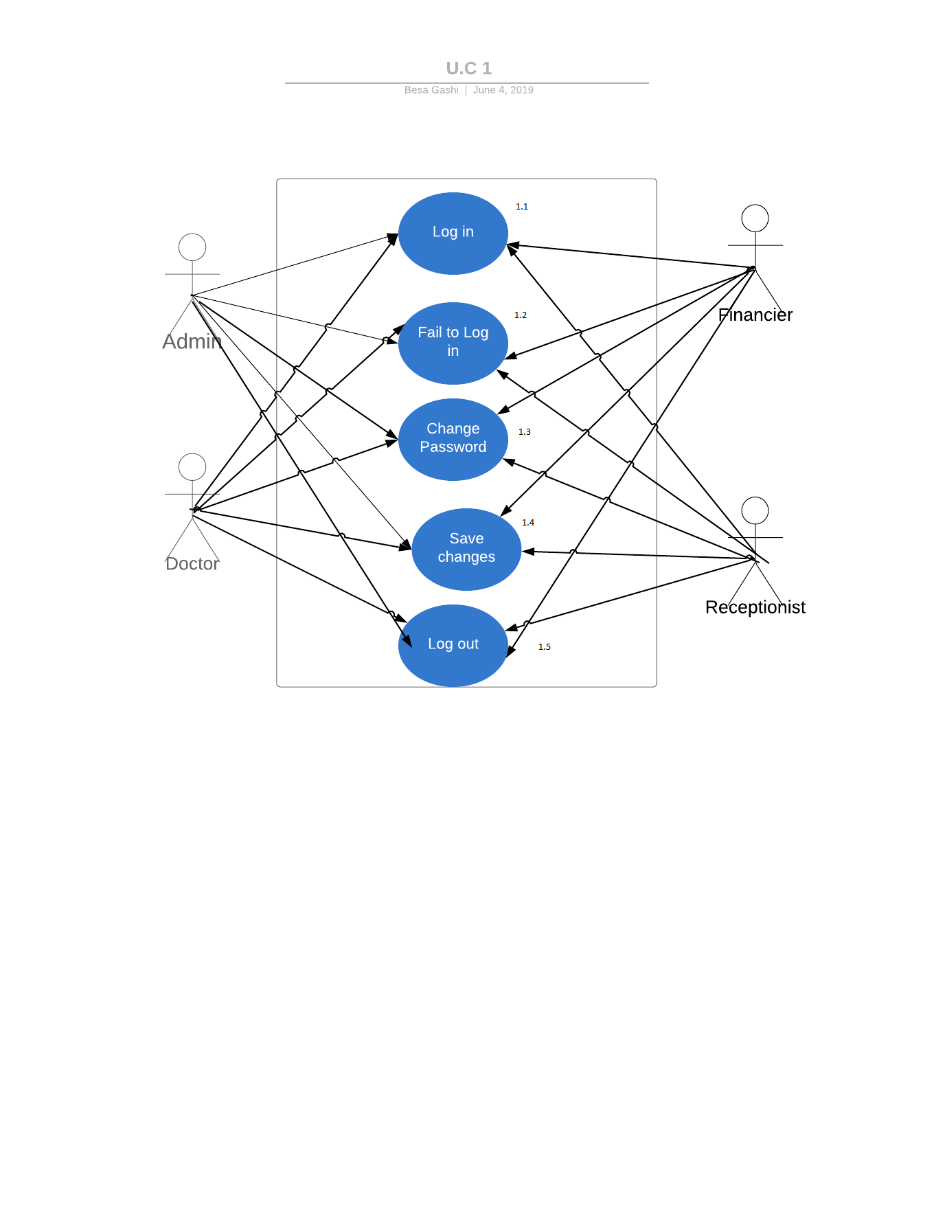

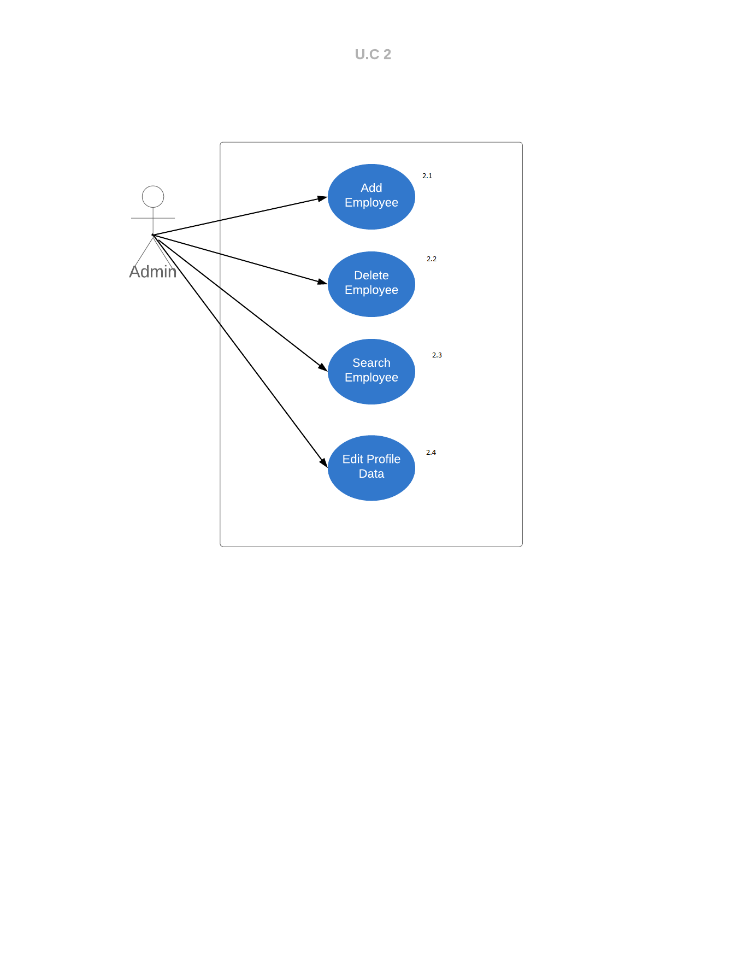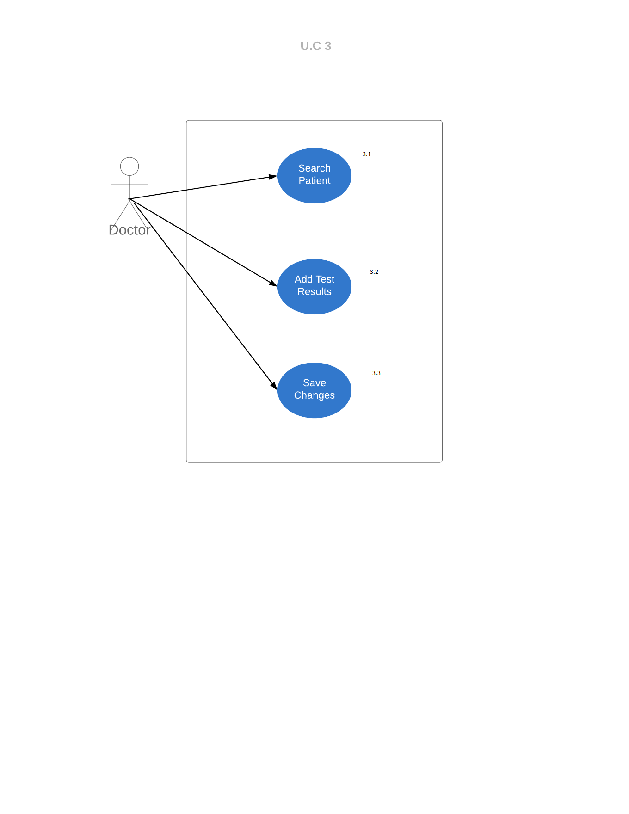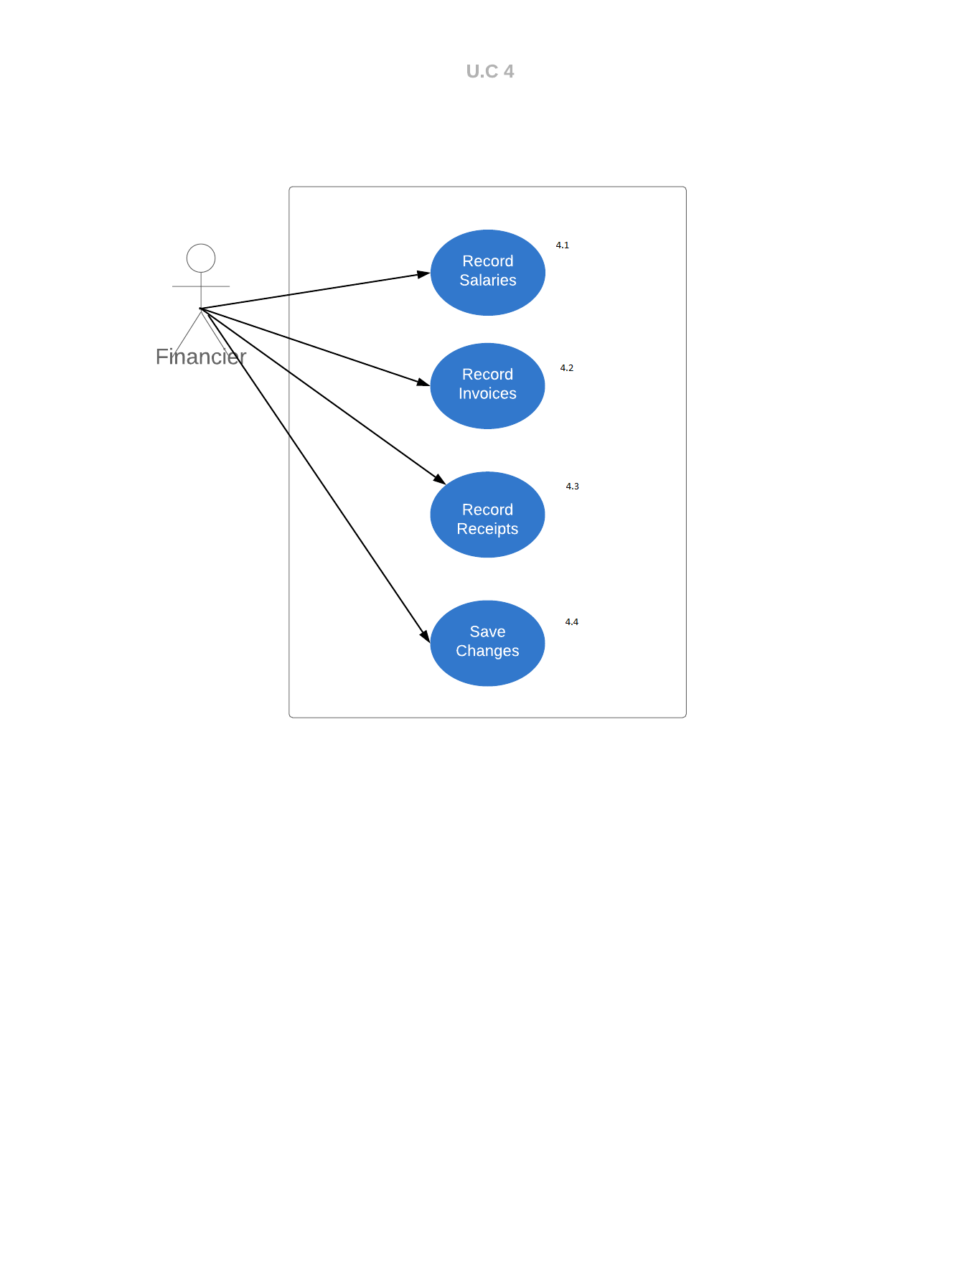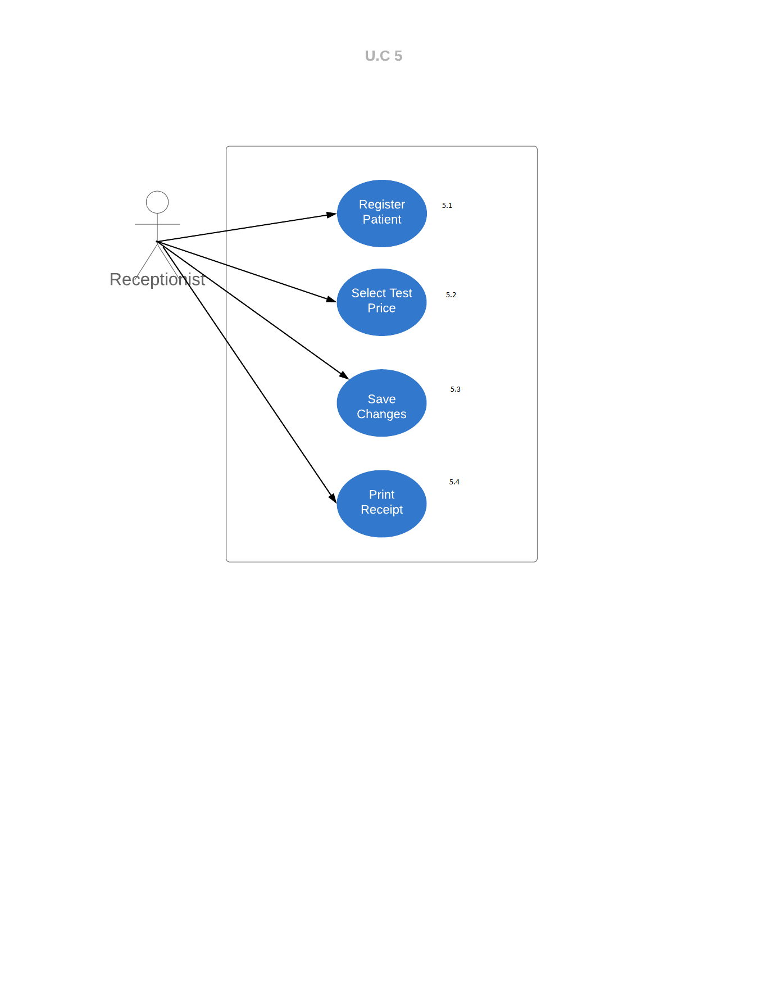

Activity Diagrams

***Activity diagram 1. UC 1.1-2.1-1.5***

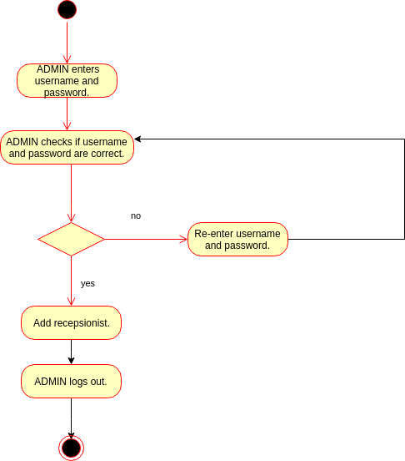

***Activity diagram 2. UC 1.1-2.1-1.5***

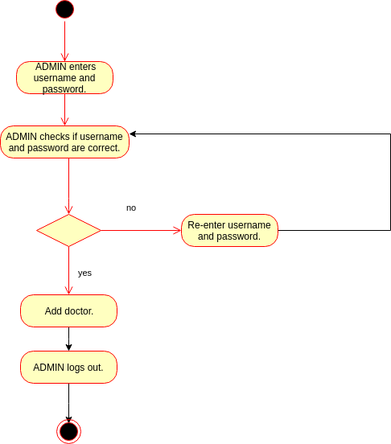

***Activity diagram 3. UC 1.1-2.1-1.5***

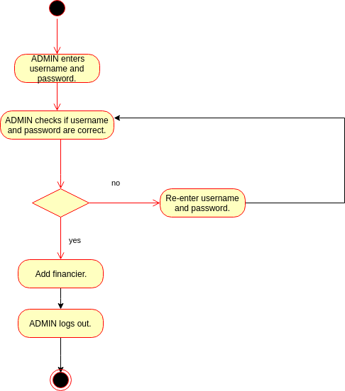

***Activity diagram 4. UC 1.1-2.2-1.5***

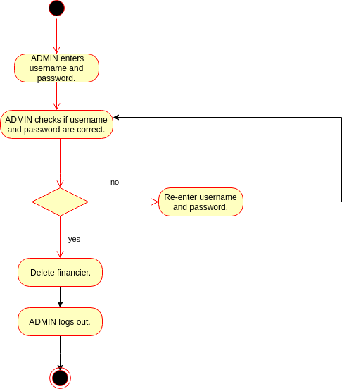

***Activity diagram 5. UC 1.1-2.2-1.5***

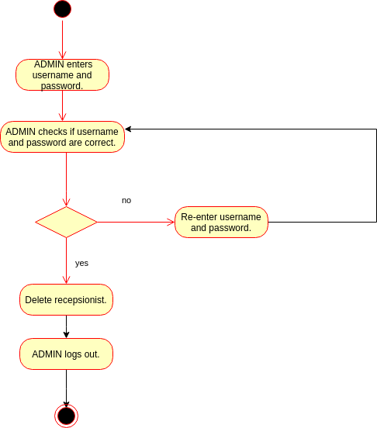

***Activity diagram 6. UC 1.1-2.2-1.5***

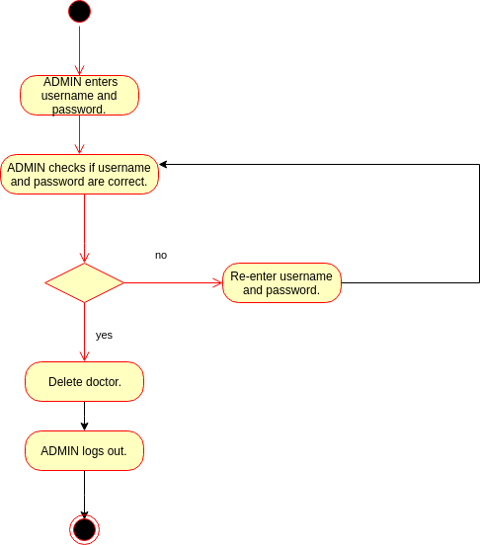

***Activity diagram 7. UC 1.1-2.4-1.4-1.5***

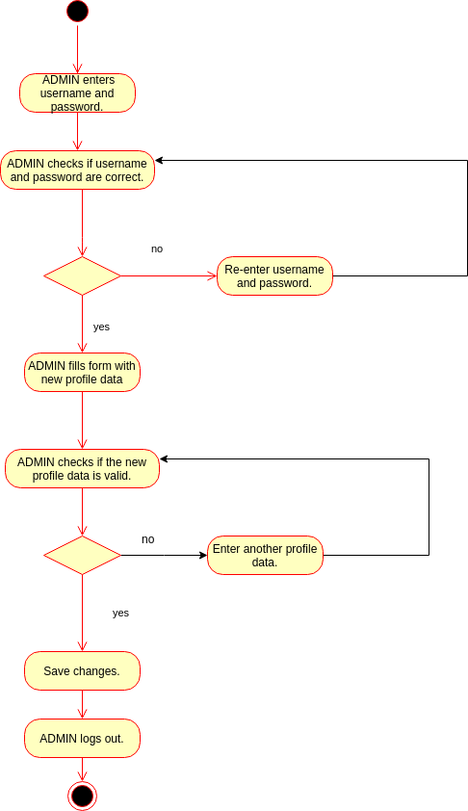

***Activity diagram 8. UC 1.1-2.3***

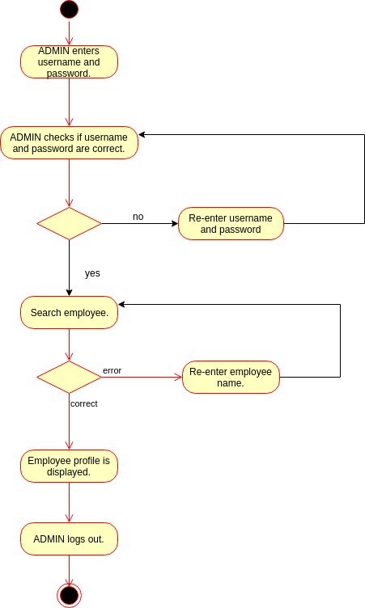

***Activity diagram 9. UC 1.1-1.3-1.5***

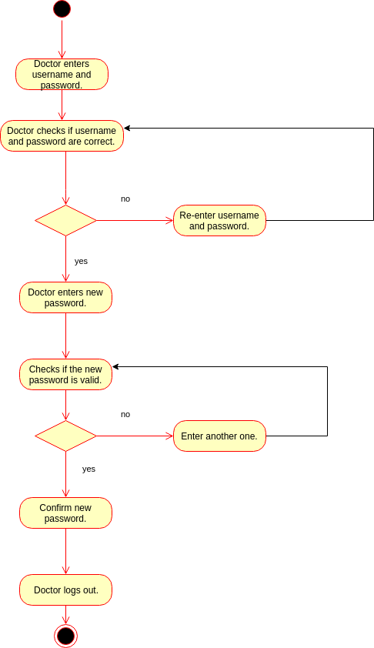

***Activity diagram 10. UC 1.1-1.3-1.5***

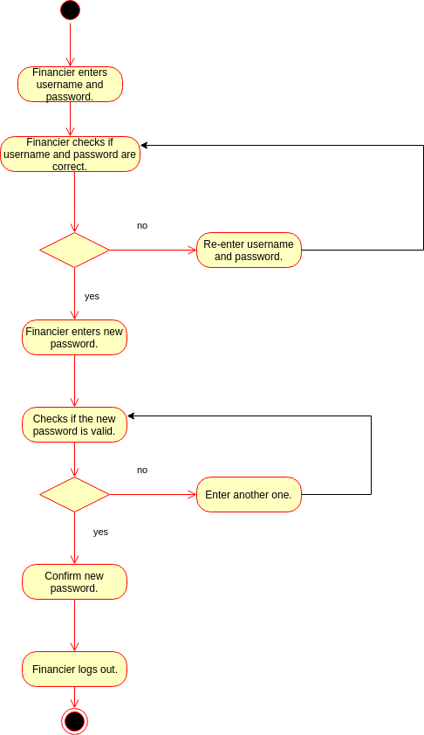

***Activity diagram 11. UC 1.1-1.3-1.5***

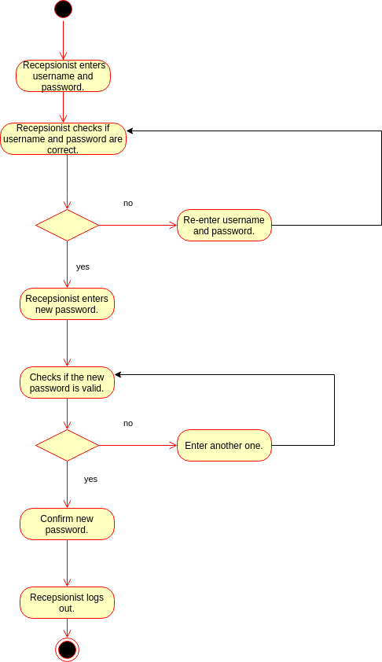

***Activity diagram 12. UC 1.1-3.1-3.2-1.5***

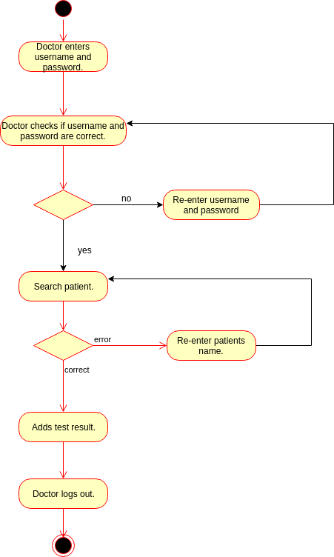

***Activity diagram 13. UC 1. 1-4.1-4.4-1.5***

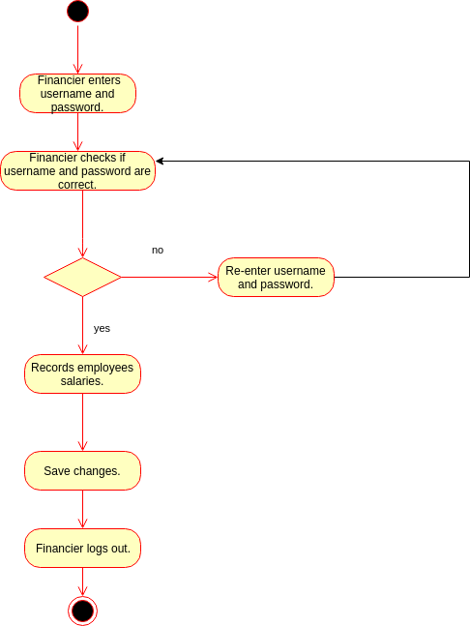

***Activity diagram 14. UC 1.1-4.2-4.4-1.5***

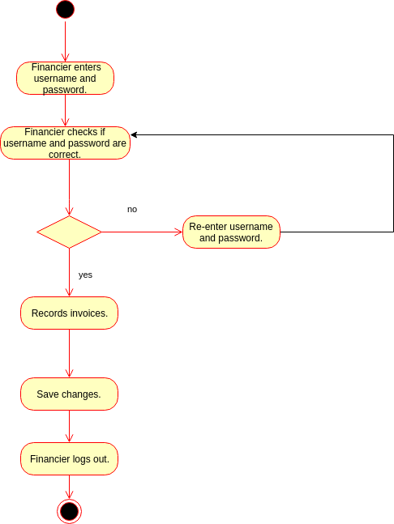

***Activity diagram 15. UC 1.1-4.3-4.4-1.5***

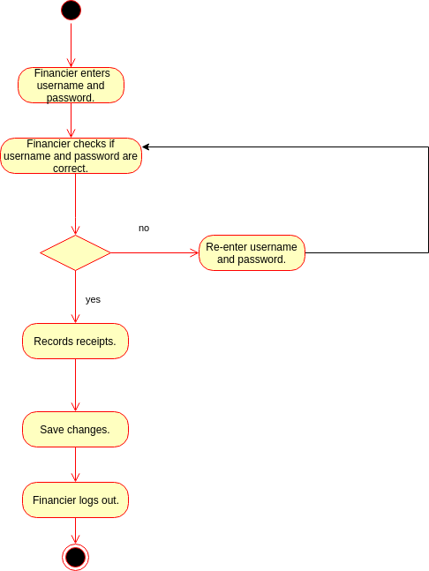

***Activity diagram 16. UC 1.1-5.1-5.2-5.3-5.4***

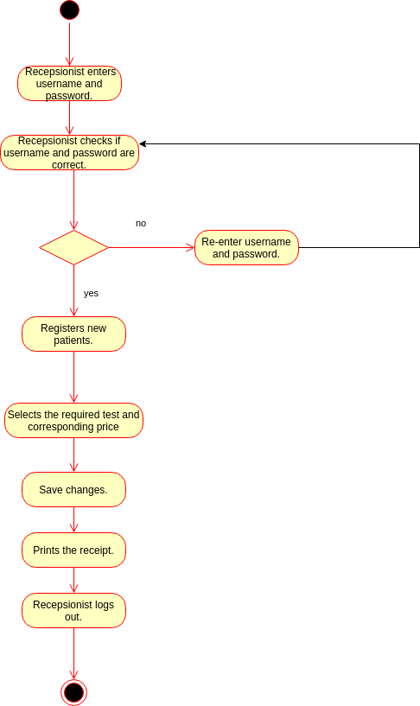

State Diagrams

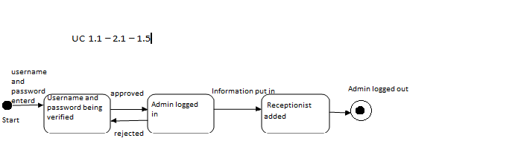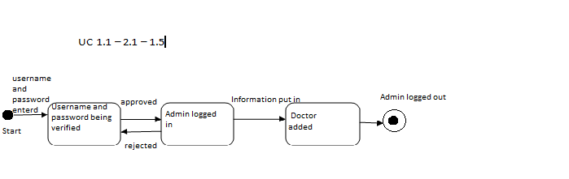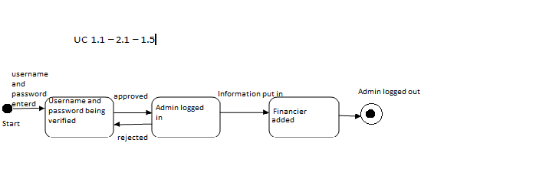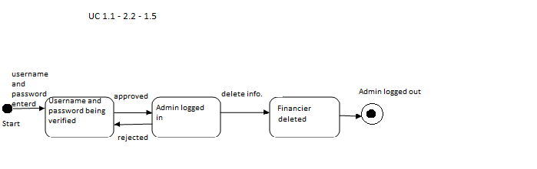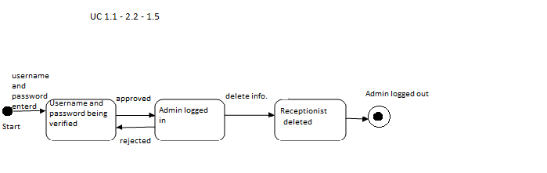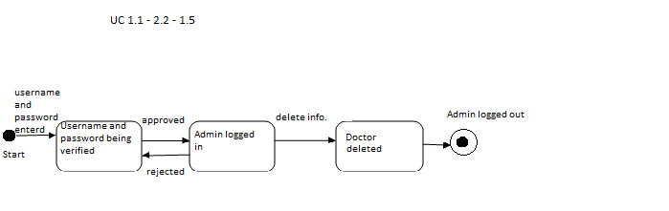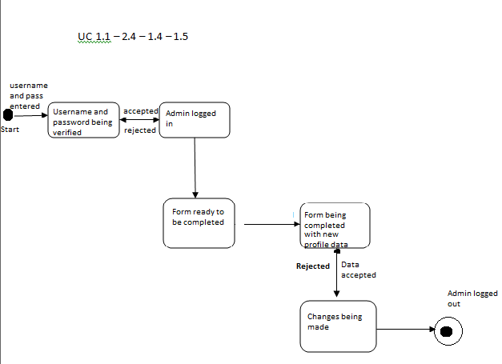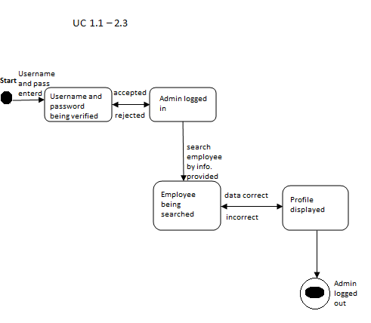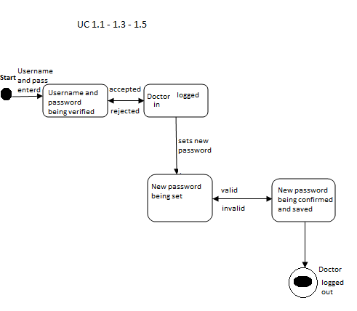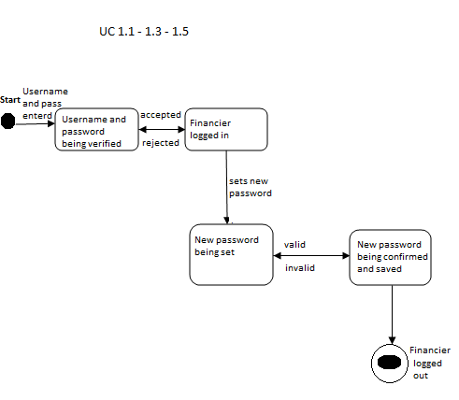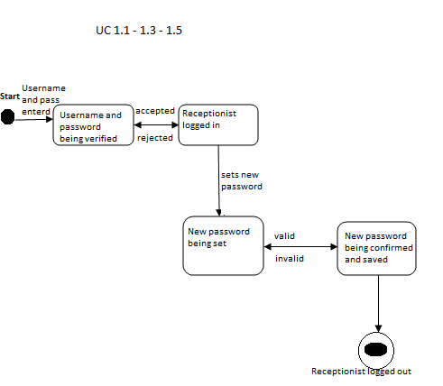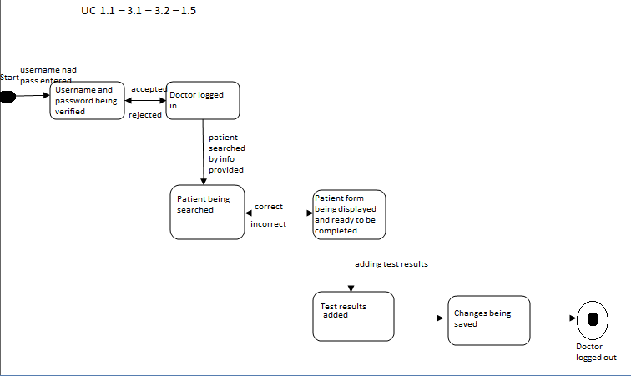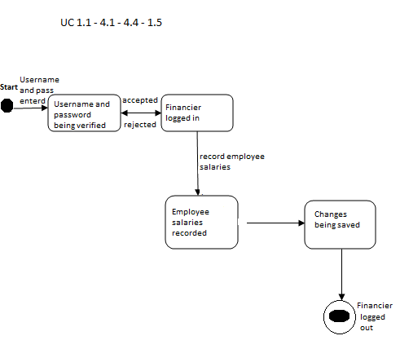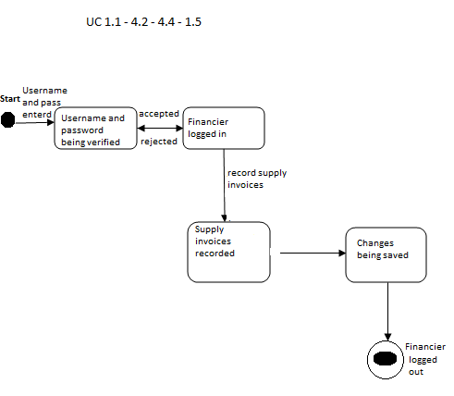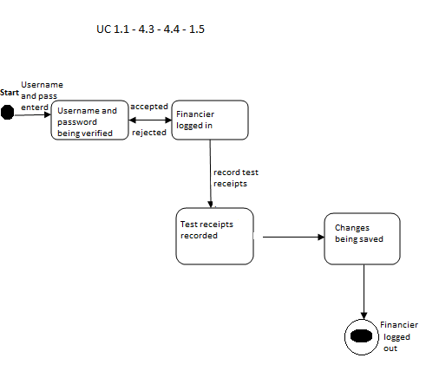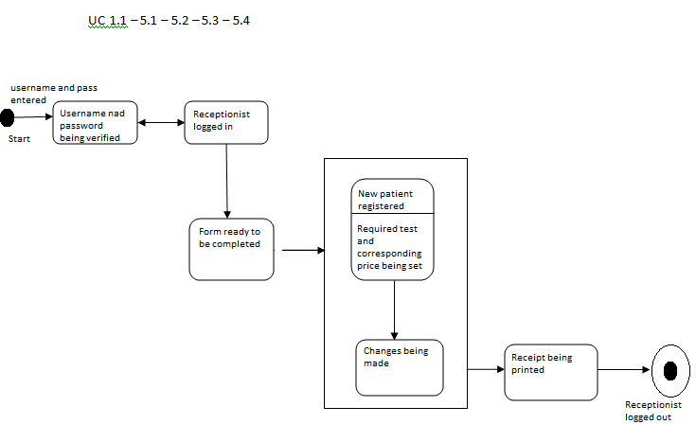

Sequence Diagrams

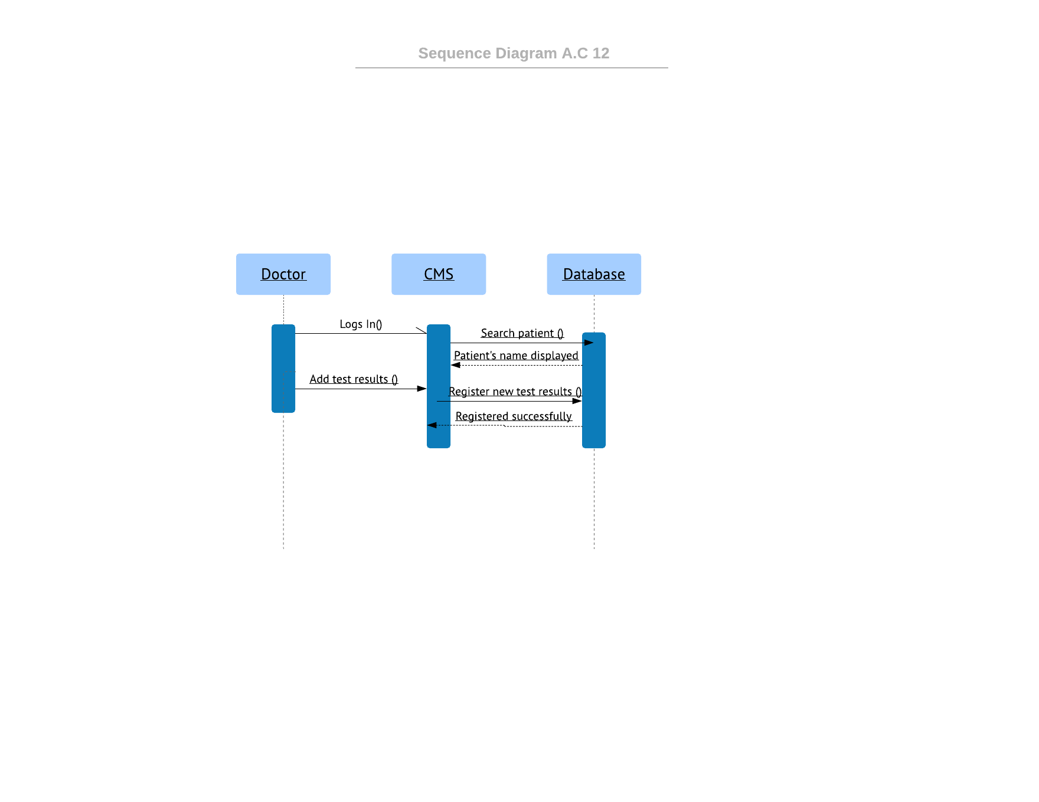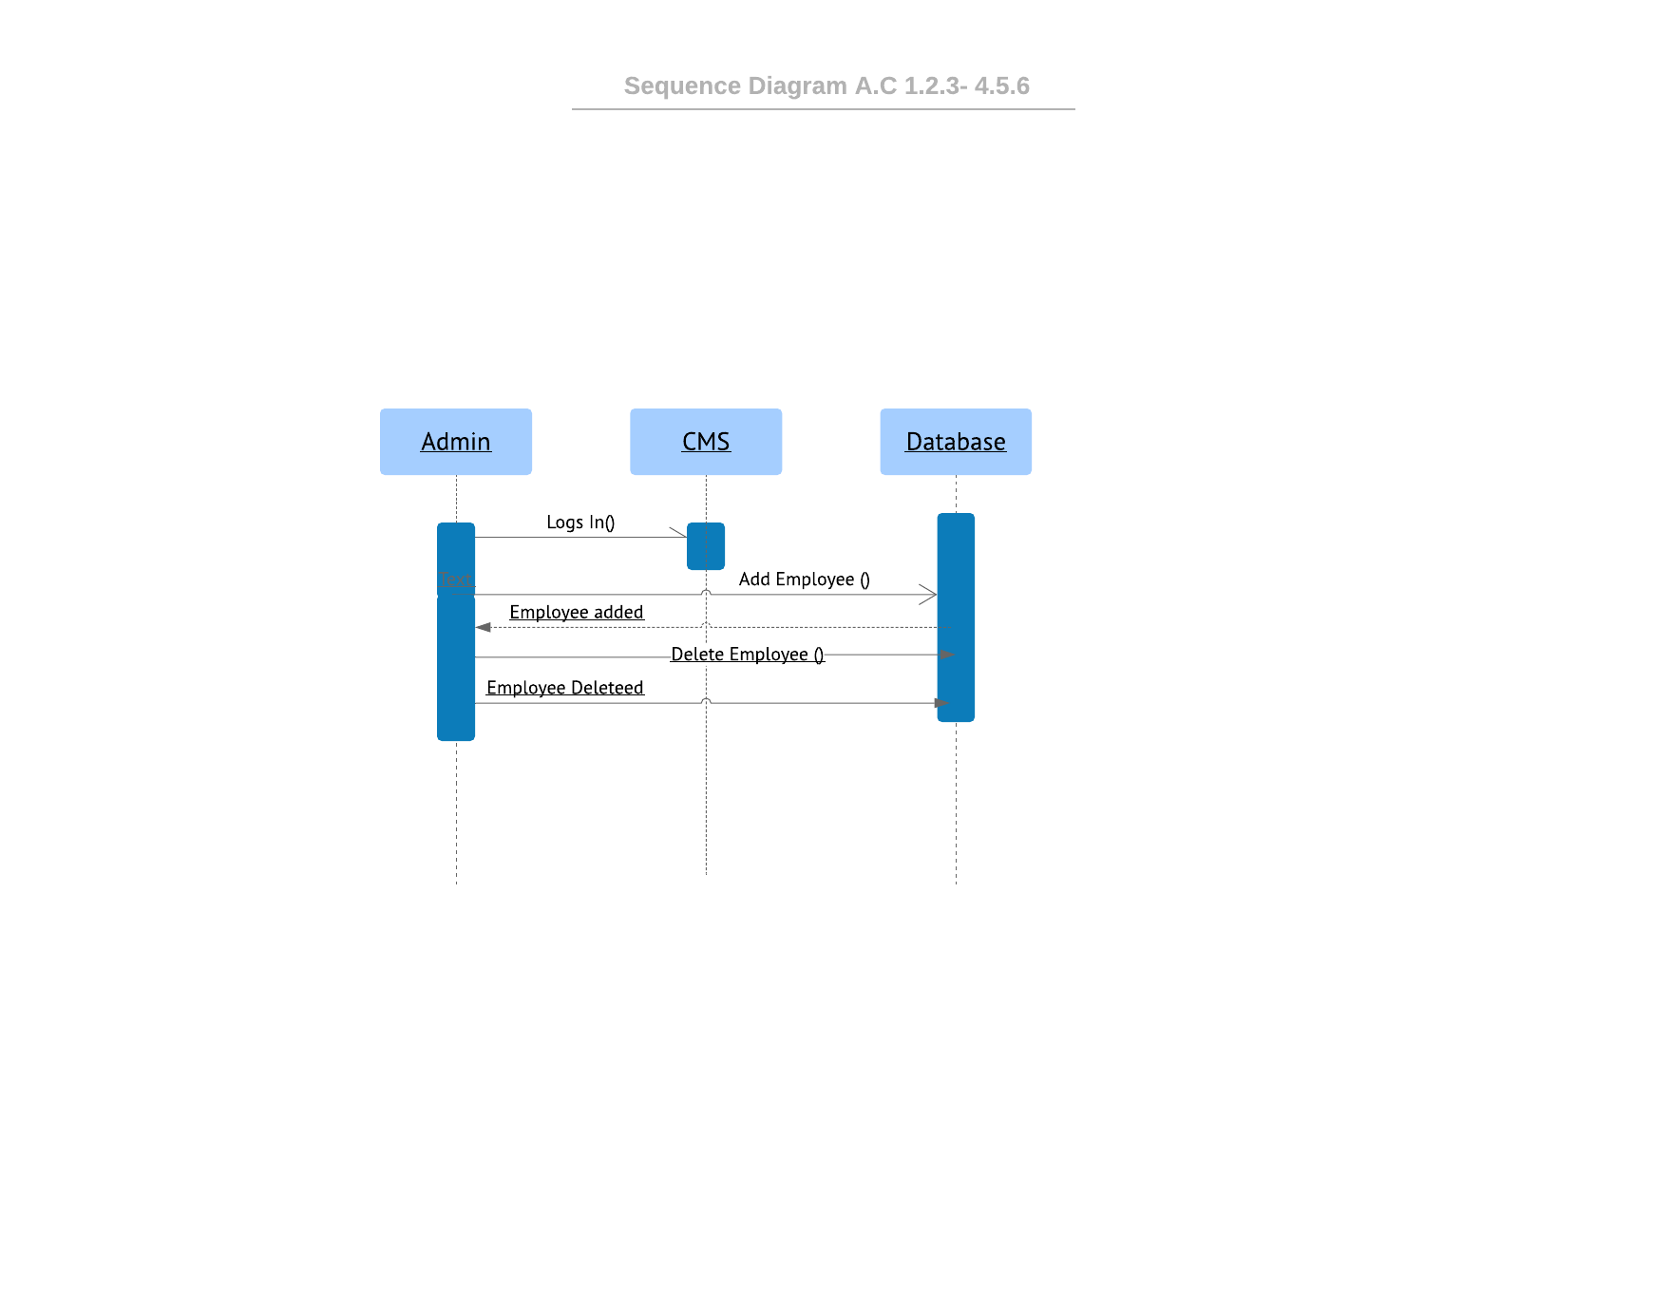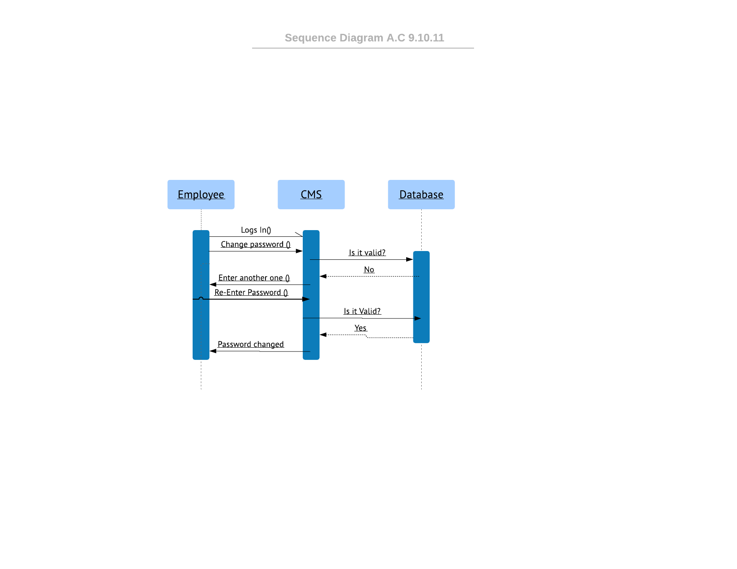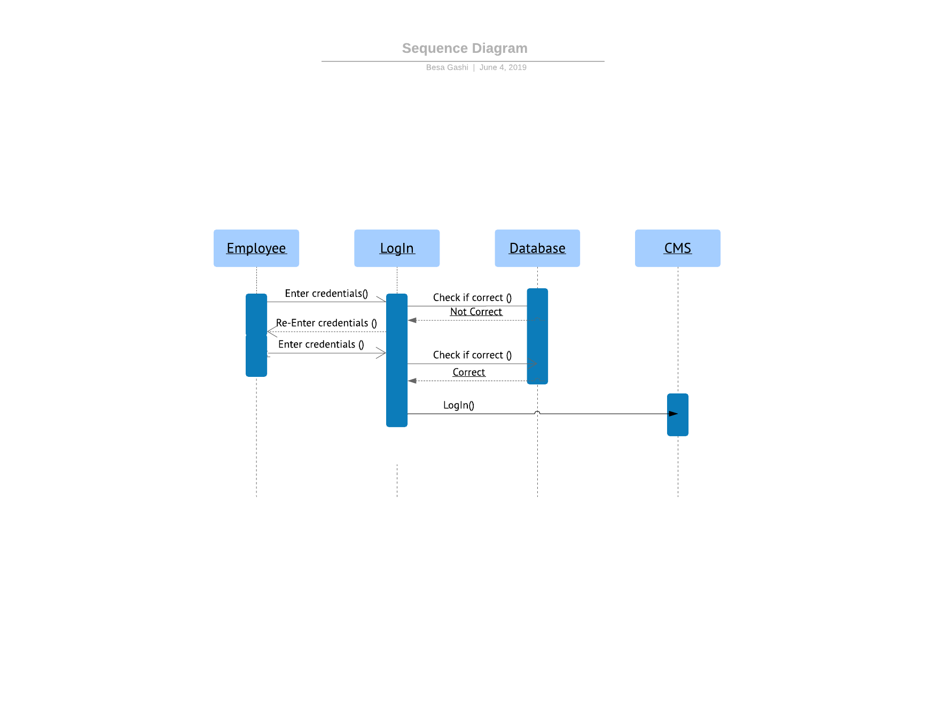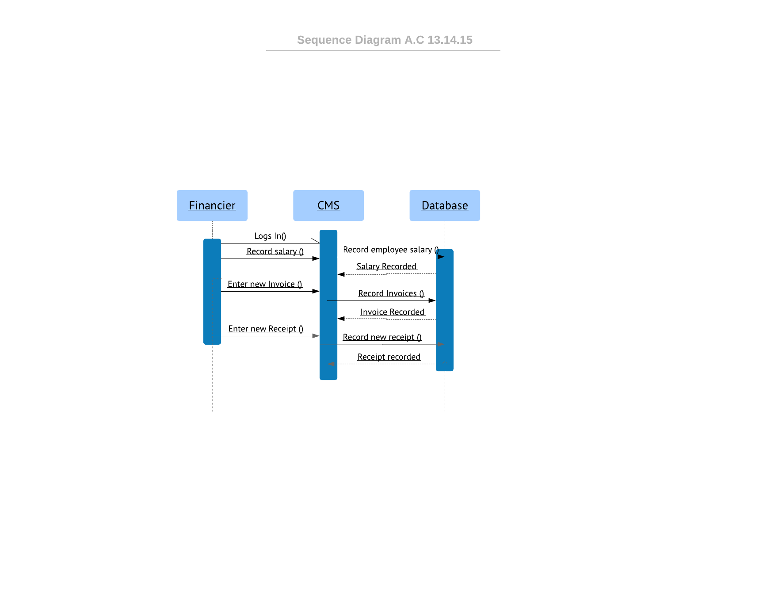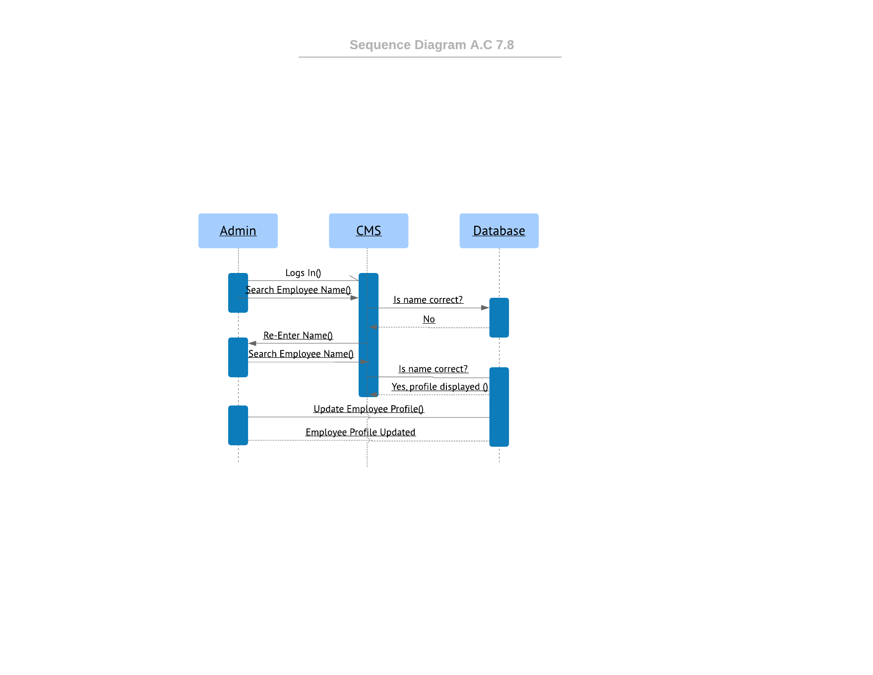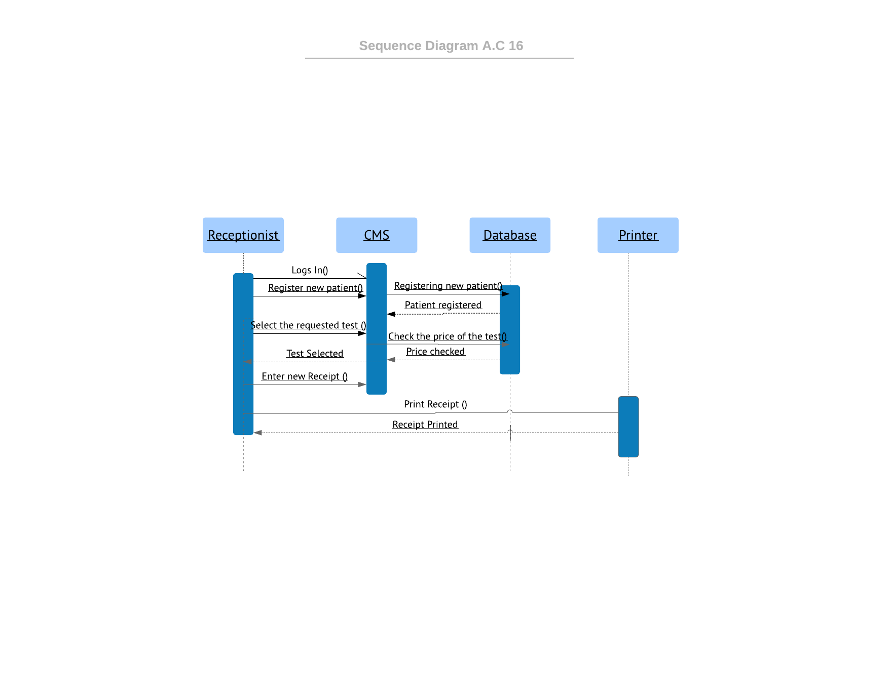

**Class Diagram**

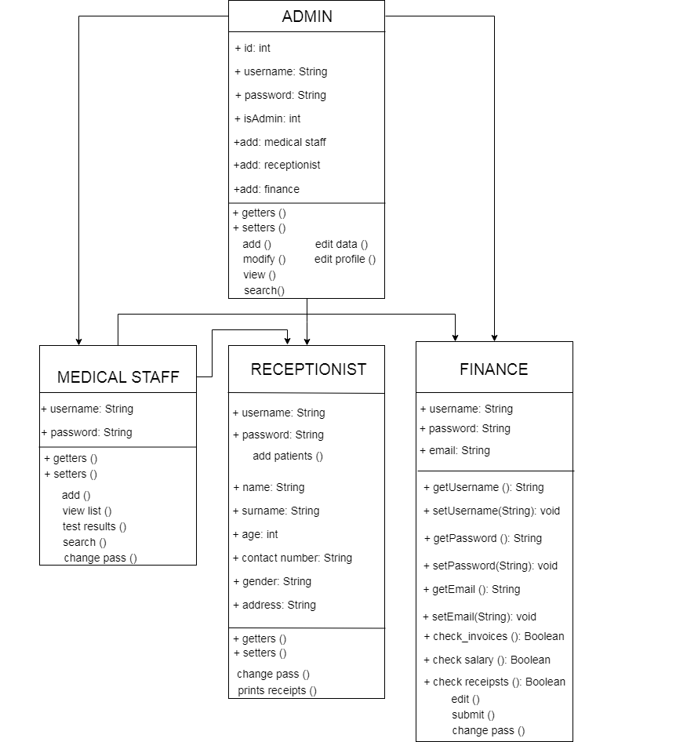

**DFD**

**Level 0**

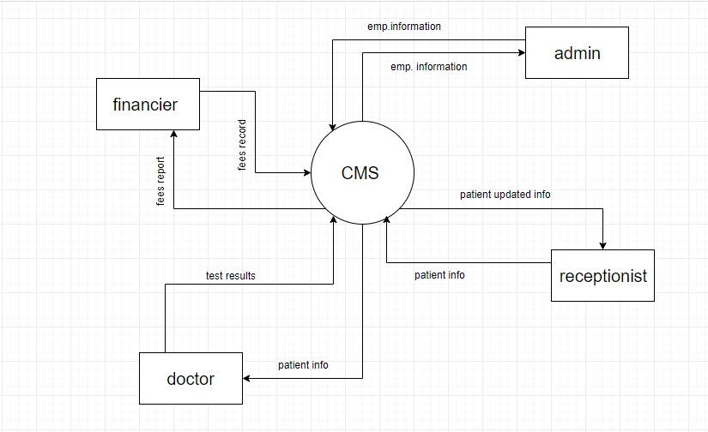

**DFD Level 1**

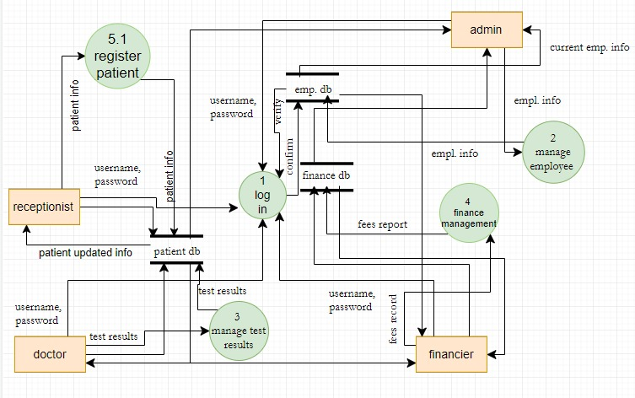

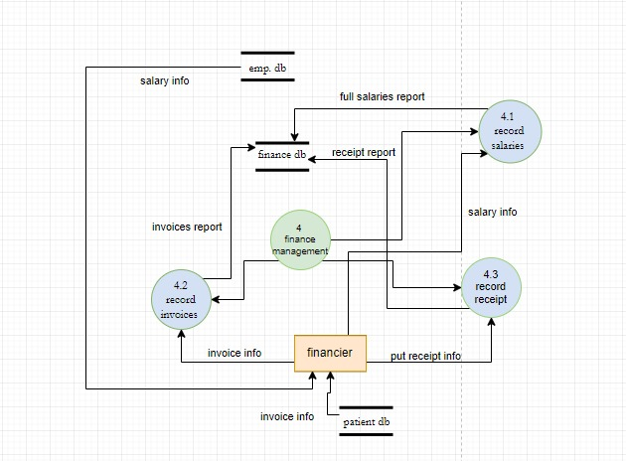**Level 2 financemanagement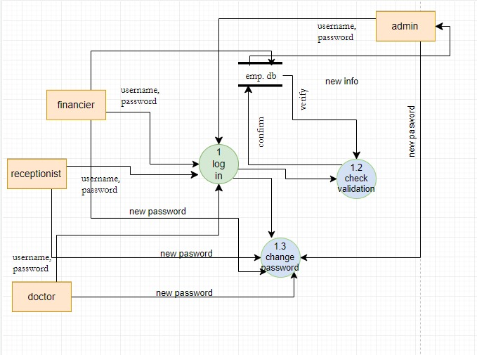Level 2 log In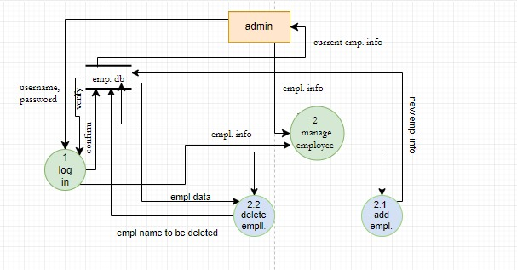L.2 manage employees**

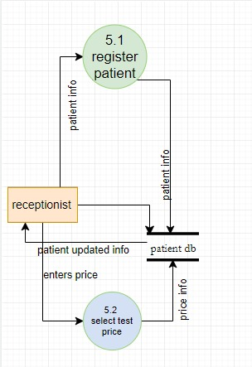 **level 2 Register patient**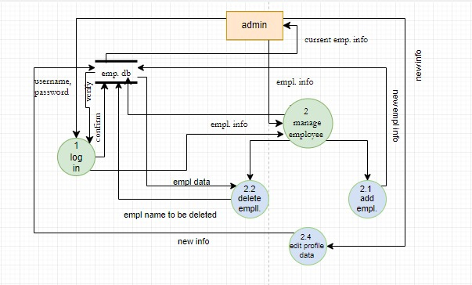

**Level 3 Manage employees**

**ERD**

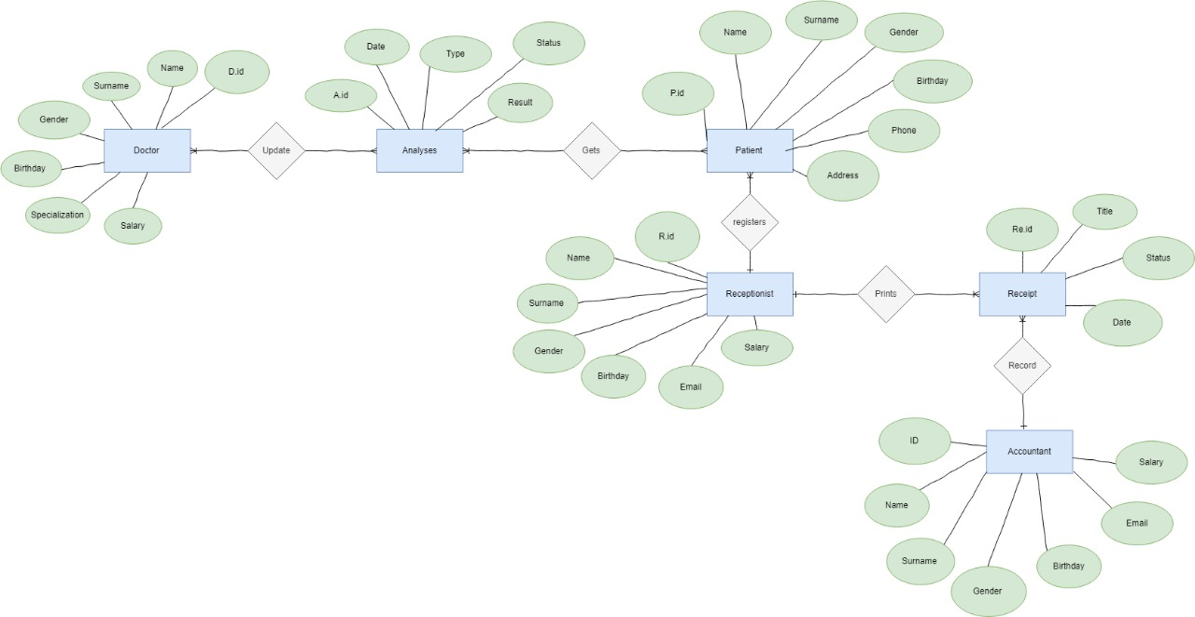

**Component Diagram**

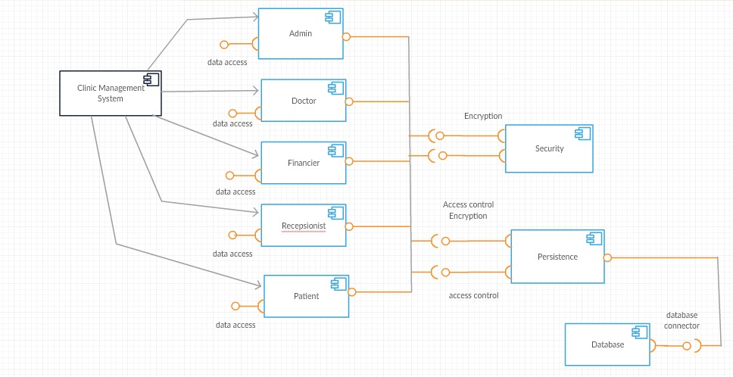

Relational Schema

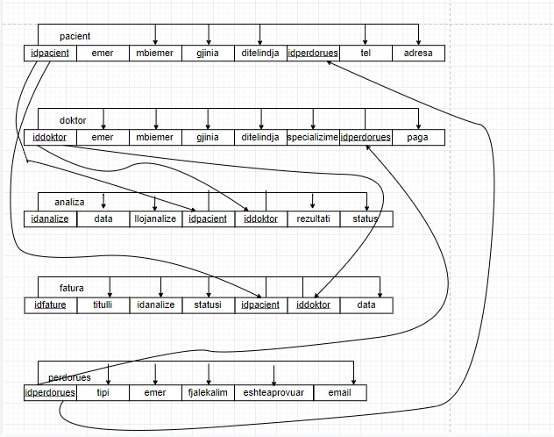

# Implemented technology

CMS is a dynamic Web Application. For the creation of this software, we have combined Client-Side Scripting and Server-Side Scripting. The communication between the client and the server will take place via HTTP protocol.

1. For the Client-Side Scripting we have used the following technologies:
2. HTML 5 (Hypertext Markup Language)
3. CSS 3 (Cascading Style Sheets)
4. JavaScript
5. Ajax (Asynchronous JavaScript and XML)
6. jQuery (JavaScript Framework Library)

We have used the libraries of Bootstrap, to make the software intuitive and easier and more attractive for the user. For the Server-Side Scripting, we have used PHP. This allows the users to interact with the software and with each other..

We must emphasize that some of the features have not been implemented completely, because of some unexpected problems, that occurred in code implementation and not managing the time efficiently enough.

User Manual

Admin logs in first with username admin and password 12341234 which is auto generated from the system. Then the admin can add employee users and work on their data profile and login information. Each employee has its own profile which can do only the task they’re assigned for. Our project can be accessed only through a web page and from any browser, it’s an web app so there’s no need to be installed on local computers. Below I am going to post some screenshots on how our software looks like.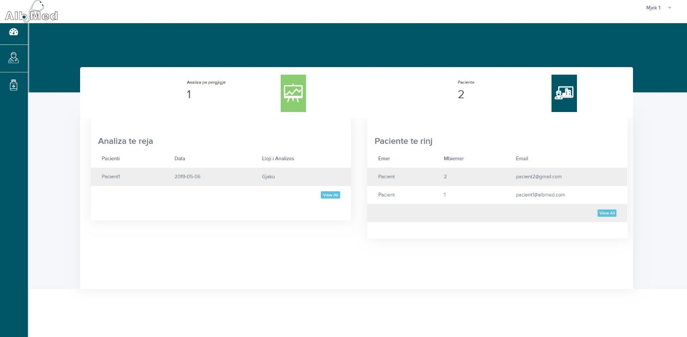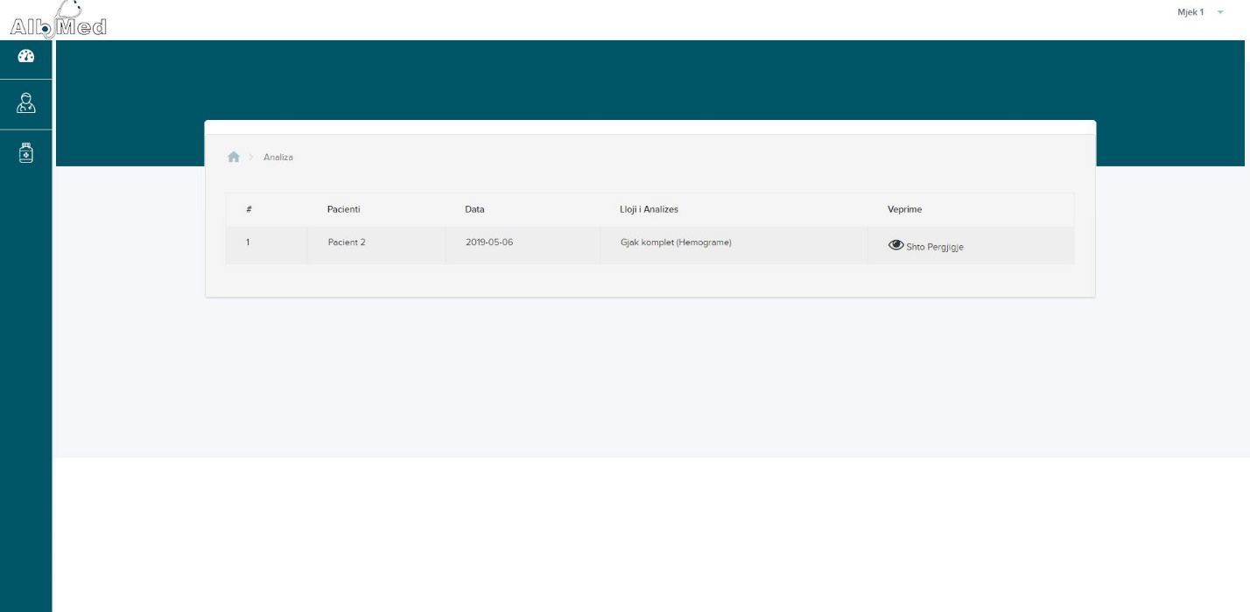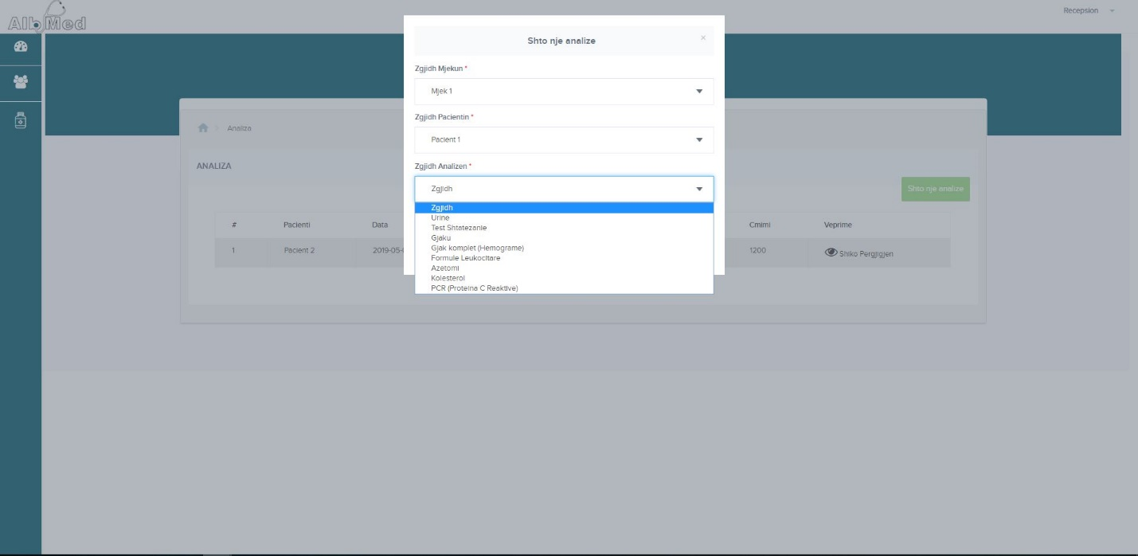i